**Things to do in Pasadena:**

**Meta description**

If you want to enjoy the beauty of nature, spent a few days in a pure and luxurious environment, viewing the splendiferous sights then definitely you visited this beautiful city and memorized your few moments of life.

**History**

Pasadena finds at the San Gabriel Mountains base, fair 11 miles northeast of Downtown Los Angeles. Known as the City of Roses, Pasadena is most famous for its Modern Year's Day Rose Parade and Rose Bowl Game. When you listen to Pasadena, you likely right away think 'Rose Parade,' but The City of Roses has bounty more to offer than fair that. With a remarkable history and culture all its possess, there is a bounty of attractions in Pasadena that make it one of the only captivating parts of the L.A. district to investigate, and there are lots of things to do in Pasadena.

Located 10 miles from Los Angeles, Pasadena invites guests with 300 days of daylight, tree-lined roads filled with notable architecture, national points of interest, well-known craftsmanship & social teach, eye-catching retail, and an assorted choice of restaurants.

**Introduction**

There's no denying that Pasadena could be a stunning city. With notable buildings, delectable scenes, and California daylight that provides plenty of light, Pasadena is the idealize put to allude. Nestled at the San Gabriel Mountains base, the city is a desert spring from the hustle and flurry of downtown Los Angeles, found an insignificant 10 miles away.

Pasadena will never be as bustling as Hollywood or as horrendously stylish as the Eastside, but that's what makes this city in the San Gabriel Valley so pleasant. Set against the San Gabriel Mountains, the town packs terrible things to do without feeling either frenzied or languid. You'll go shopping along Colorado Boulevard, visit turn-of-the-century houses and climb Resound Mountain, all inside the space of an afternoon.

**9th largest city in Los Angeles**

The 9th biggest city in Los Angeles Province, California. Pasadena, maybe a safe house for guests who appreciate sports, the expressions, or the sciences. The city is known for numerous things; from the yearly Rose Bowl football amusement to the California Organized of Innovation, various points of interest make Pasadena an incredible get-away spot for the whole family and enjoy different things to do in Pasadena. The Southern Californian city is additionally known for the Competition of Roses Parade, a yearly occasion held since 1890 to exhibit imaginative coasts made with blossoms and greenery.

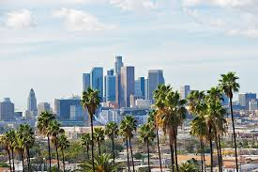

**The sun and palm trees**

Pasadena's sun and palm trees are broadcast to the world each January 1st, as best college football groups compete within the Tournament of Roses at the city's regarded Rose Bowl Stadium. Nearby football and tailgating, Roses' Competition bring the broadly celebrated Rose Parade to the lanes, with colorful flower courses of action and show. All through the rest of the year in things to do in Pasadena, Rose Bowl Stadium is still the put to be, with live music entertainment and community occasions just like the world's greatest

insect market.

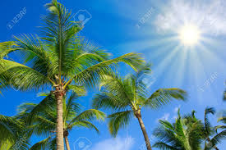

**Cultural experience**

With central teach, social encounters flourish in Pasadena, just like the Norton Simon Gallery and USC Pacific Asia Historical cent advertising lifetimes of instruction. For a feeling of getting out of the city without ever really taking off, The Huntington Library, Craftsmanship Collections, and Botanical Gardens include over 200 sections of land of unpredictably arranged characteristic space, world-renowned works of art, and extensive investigate offices. For a genuine elude, the Angeles National Woodland and San Gabriel Mountains are the city's backyard.

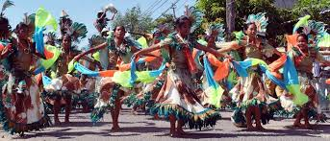

**16 Things to do in Pasadena:**

Whether you're investing a day or a complete end of the week here, you can't go off-base with these 16 fundamental things to do in

Pasadena.

**The Gamble House**

A California and National Notable Point of interest can blend in with another well to do rural homes on Westmoreland Put in Pasadena. Construct in 1908, and the Bet House had a place to the on-screen Dr. Emmett Brown within the Back to long Haul set of three. Off-screen, this three-story architect's dream was included within the beat ten houses list of all time by the Los Angeles Times in 2008 and encompasses a yearly pivoting inhabitance of design understudies from USC. Drop-in on a Tuesday when the raised garden and porch are open for Brown Bag lunch carriers or day by day planner based tours things to do in Pasadena.

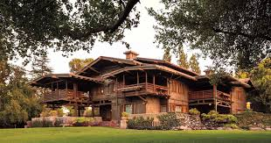

**Pasadena Playhouse**

The 686-seat notable performing expressions scene is a compelling medium for the American Theater. The Pasadena Playhouse was the primary American theater to create all of Shakespeare's plays and exhibit at least 300 exhibitions every year. Their College of Theatre Expressions wrenched out incredible on-screen characters counting Quality Hackman, Dustin Hoffman, and box office heartthrob William Holden. Nowadays, The Whipping Man by Matthew Lopez is onstage until Walk 1st, and Pygmalion and Waterfall make a big appearance afterward this spring and summer. These are great things to do in Pasadena.

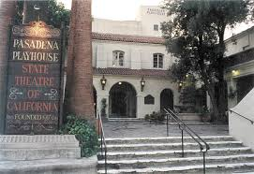

**Huntington Library**

The Huntington Library serves as a double reason foundation by exhibiting instructive and inquiry-based collections and 120 acres of arranged gardens. There's an affirmation expense to visit, but they offer "Free Days" for non-member guests on the primary Thursday of each month. You'll need to ask for your ticket in progress online or by phone to maintain a strategic distance from a sellout. There are four feasting options here for when your feet require a rest counting the Rose Plant Tea Room where you'll gently eat finger sandwiches and chilled servings of mixed greens of The Café for a family inviting alternative with basic, however fulfilling choices such as sandwiches, tacos, quesadillas, and a kid endorsed children's menu, and that are different things to do in Pasadena.

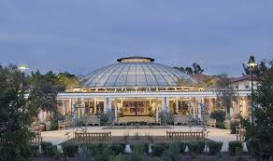

**Ice House Comedy Club**

Open since 1960, and this vintage-Esque comedy club has been Pasadena's go-to for music and comedy. Eminent comedians have graced this club, counting Jay Leno, Jerry Seinfeld, and the late Robin Williams. Nowadays, there are two showrooms, a yard, and around 7,000 visitors each month. Up and coming entertainers incorporate Harry Basil and Kevin Smith with Jason Mewes. I would attempt looking at Groupon for the most recent and most prominent bargains for passage into this comedy club thing to do in Pasadena.

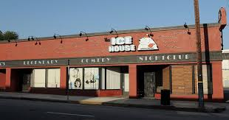

**Old Town Pasadena**

Pasadena's genuine downtown has numerous exercises and foundations for those seeking out fun within the City of Roses. Take a walk along Colorado Blvd. in ancient town to appreciate a heap of shopping and feasting choices. Furthermore, there's the Farmer's Showcase each Sunday with free kids' exercises. And, of course, each year, people camp out along Colorado the day sometime recently the turn of the current year so they can stake out their genuine domain to observe the yearly Rose Parade.

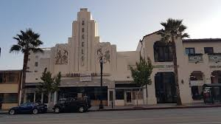

**Rose Bowl**

Talking of roses, the Rose Bowl can be most broadly knew for the yearly college football diversion of the same title. Still, regular flea markets, concerts, and extraordinary occasions draw within the swarms year-round. To of note, stadium visits are made available for those genuinely fair interested where guests can see the first 1922 locker room, the Loge Relax, and all the famous history that has happened here things to do in Pasadena.

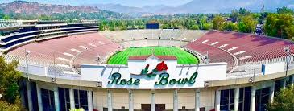

**Kidspace Children's Museum**

Typically they put to visit on the off chance that your family has small ones in it because, some of the time, kids require a trip that's all around them. There are many hands-on shows for our small ones, which are utilized to hearing, "don't touch!" and a bounty of open-air activities and programs. The open-air Robert & Mary Galvin Material science Woodland looks like a phenomenal put to let kids utilize their wholes bodies and intellect to see how things work. Check out their site for current programs adapted for all age ranges.

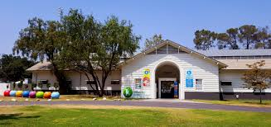

**Norton Simon Museum**

One of the foremost impressive private collections within the world resides at the Norton Simon Exhibition hall, many fair squares west of Ancient Town Pasadena's heart. Works extending from 2,000 years incorporating art from the European Renaissance, 20th-century European experts, and extraordinary figures from South and Southeast Asia made more than a millennium back to do in Pasadena. Standard admission is $12, but the Exhibition hall is free for all guests on the primary Friday of each month from 5 pm to 8 pm.

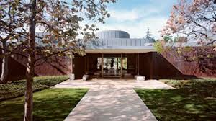

**Santa Anita Park**

I kept in mind when all I utilized to listen almost on the radio and tv was the Santa Anita Stop. The stop, which is best known for its pure breed dashing, is in season right presently until June. You'll be able to capture a race and a free visit of the stables ends of the week amid the season at 8:45, and 9:45 am. They've got more than fair steeds even though different and unique things to do in Pasadena. If you like a lager, they've got a brew celebration coming up early Walk and the Winner's Circle BBQ Championship after Walk. You're bound to have a busy spring and summer on the off chance that you remain current with the occasions this scene hosts.

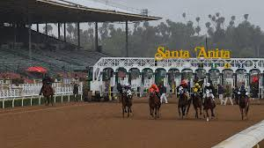

**Propulsion Laboratory**

Generally, once a week, the lab opens its entryways to the open; the 2- to 2.5-hour visit starts with a mixed media diagram of the set-up. The open area appeared around the Space Flight Operations Office and the Shuttle Gathering Facility. Demand is tall, and booking well ahead is basic; security concerns manage that U.S. citizens have to bring an international id or driver's permit. Other nations' citizens must announce their nationality earlier to booking and getting a visa green card on the day. For full security and booking subtle elements, check the website.

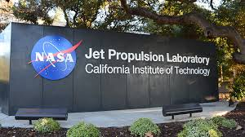

**Colorado Street Bridge**

This century-old span over the Arroyo Seco is known for its Beaux Expressions curves, and a new one to do in Pasadena and its fantastic light the backdrop for a nightfall walk in La La Arrive. A fast aside: The point of interest has earned the sad moniker "Suicide Bridge" due to its part in inopportune passings dating back to the Extraordinary Depression.

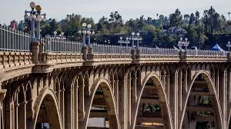

**Brookside park**

Fair south of the Arroyo Seco's most popular 62-acre stop (which incorporates Kidspace Children's Exhibition hall) provides a picturesque green space for local people out-of-towners alike. Set against the dazzling San Gabriel Mountains, you'll discover plenty of open space to run and play among the multipurpose sports areas, together with a few shades close to the privateer ship-themed playground things to do in Pasadena. There's an appropriate wellness path around the stop, but you'll discover numerous active visitors running and biking along a way that flanks the complete east side of the park.

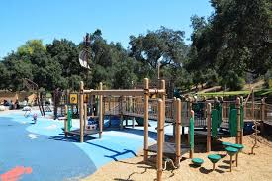

**Gabriel Mountains**

Take after Lake Road into neighboring Altadena and to the street's northernmost conclusion to reach the Sam Merrill Path, which follows the ruins of the ill-fated Mount Lowe Railroad. On the off chance that you're feeling ambitious like five-plus miles and a 1,500-foot rise pick up ambitious you can climb up Reverberate Mountain. Make it approximately midway up, and you'll still be able to come across the railroad ruins things to do in Pasadena. Make it no more distant than the level trailhead, and you'll even reimburse with a quiet fix of nature.

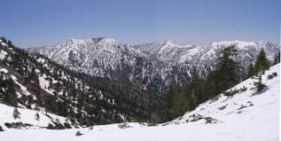

**Castle Green**

There is a bounty of buildings that bring out ancient Hollywood glamor. Still, nothing summons a discussion of Plated Age riddle and tastefulness like this last lodging thing to do in Pasadena. The initial building within the three-part complex annihilates within the '30s, but the more impressive Moorish-meets-Victorian central attach still stands behind a shade of rich gardens. The building offers two insides tours a year, but it's always worth strolling by fair to see its striking exterior.

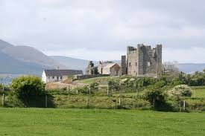

**Canyon Nature Center**

Found at the base of the San Gabriel Mountains, the Eaton Canyon Nature Center could be incredible. Spend the day drenched in nature; guests of all ages can come to investigate the 7,600 square-foot building and the encompassing 190 sections of land of zoological, botanical, and geographical nature protection that it sits on.

Investigate the streams, rocks and minerals, local plants, territories, and the natural life within the encompassing region. The center itself fills with intriguing shows and shows, as well as live creatures. Guests can also appreciate climbing and equestrian trails, and there may be an organizing region and outing zone accessible for use. Visits and planned strolls are moreover available things to do in Pasadena.

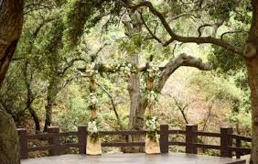

**Amazebowls**

Amazebowls was Los Angeles' to begin with a bowl truck at its opening in 2013. Nowadays, the trade offers several lasting locations through the Southern California locale in expansion to its meandering nourishment trucks, counting an area in Pasadena. It strives to create a reliable eating hip and open for all coffee shops, making high-quality superfood bowls that are 100% vegetarian, dairy-free, and free of refined sugars. Burger joints can appreciate the company's signature Amazebowl, highlighting an a base topped with bananas, strawberries, blueberries, and vanilla almond granola things to do in Pasadena. Other signature bowls highlight fixings such as kale, match a, spirulina, kiwi, and whole-grain oats, served up in intelligent holders like half coconut shells. Moreover, burger joints can create their claim bowls, choosing from pitaya, turmeric ginger, and actuated charcoal bases topped with their choice of superfood ingredients.

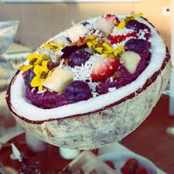

**Conclusion:**

The popularity of the region drew people from across the country. Pasadena eventually became a stop on the Atchison. A extraordinary tourist lodgings create within the city, Pasadena got to be a winter resort for affluent Easterners, impelling the advancement of new neighborhoods and commercial areas and expanded street and travel connections with Los Angeles means there are many things to do in Pasadena.

Pasadena includes a Mediterranean climate with ordinarily more smoking summers and somewhat cooler winters than adjacent coastal areas. It implies the traveler delighted in a lot and memorized their holidays.